Besame Cosmetics Social Media Campaign.

Historical Heroine Look-aLike Contest: Crux of Social Media Plan

An idea that would serve Besame well, is having a Historical Heroine look-alike contest.

The basis of the plan is for Besame to put up a picture and brief summary of an influential woman of the past 100 years. Good examples of the kind of people Besame will post are Bessie Coleman, Bettie Page, Noor Inayat Khan. This serves to:

- Give fans of Besame a chance to interact with the brand and express their creativity

- Reach a new market of people who are interested in beauty and history, but who aren't necessarily familiar with the Besame Brand

- Entertain and inform people of the achievements of these great individuals, while spreading the Besame name.

People who wish to enter the contest will make themselves look like the historical person that Besame posted about, post pictures with hashtags like #histori-girly or #BesameHistoricHeroines. Things will be posted to twitter to promote the contest, but the main focus for the campaign and for the contest will be Instagram.

Besame will then review the submissions and twice a week announce a winner; then, share that winner on the Besame page. At the end of the month, the winner who got the most likes and shares, will receive 150 dollars in Besame Products.

Another thing that will help give the campaign traction, is teaming up with Bloggers, Glamour Daze and Bobby Pin Blog , send them products (maybe even with a recommended historical figure that resembles the blog owners) and challenge them to recreate the look, and blog about it.

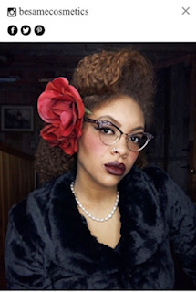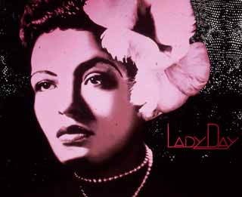

Why this works for Besame

I think this will be a good fit for Besame, because storytelling and history is essential to their brand. It is a small luxury brand and its popularity comes from its sense of fun, its quality products, and its historical timbre. This is a way for people both familiar and unfamiliar with Besame to play and have fun, and because its fun, people are more likely to engage.

Besame Cosmetics

Besame is, in their own words, “Besame first entered the market in 2006, and has grown to develop cult status with makeup lovers.”

Marketing strategies used in the past

- Partnered with Disney, to make a luxury, Snow White themed eye-makeup pallet. The venn diagram between makeup lovers and adult Disney fans is large.
- Also partnered with Marvel for their Create Agent Carter, Captain America themed makeup pallets, with a twist. They also have realized Infinity Wars lip-gloss and eyeshadow.

Social media

Twitter
- 10.2 K twitter followers.
- Following 3660
- Likes 3821
- 6529 tweets
- Joined twitter 2008

Instagram
- 2655 post
- 173 followers
- 689 following

Besame is far more active and popular on twitter, which is not the platform that needs the most focus for them. Traditionally twitter works well for the verbal but isn't as well suited to the visual as Instagram. This contest will help spread Besame visibility.

